** **

GCE/IAL applicable

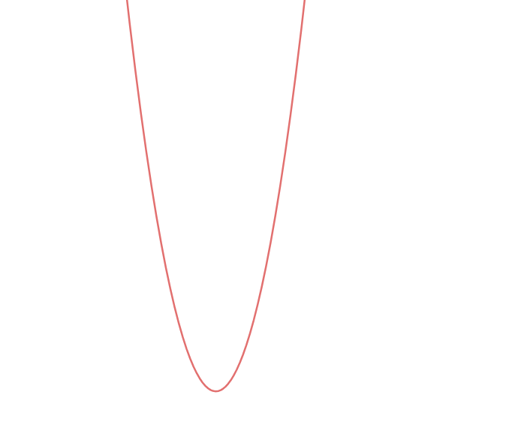

**Quadratic Functions and equations**

**For C1(GCE)/C12(IAL)**

**Content**

|  |  |
| --- | --- |
| Main Concept 1: Completing the square | **p.4** |
| Main Concept 2: Finding the axis of symmetry | **p.7** |
| Main Concept 3: Finding the vertex of the curve | **p.12** |
| Main Concept 4: Solving the quadratic equations | **p.15** |
|  |  |
|  |  |

**Quadratic Function and equation**

**Introduction to quadratic function**

$y=f\left(x\right), where f\left(x\right)=ax^{2}+bx+c;$**where $a,b,c are specific constants.$**

**There are some main points to explore**

**Complete the square**

**Find the axis of symmetry**

**Find the coordinates of minimum/maximum points**

**Find the solutions when $f\left(x\right)=0$, if any.**

**Main Concept 1:**

**Completing the square**

**Given a graph of the quadratic function, what can you see?**



**It is a curve, with specific minimum/maximum point,**

**and there is a axis of symmetry for the graph.**

**Why?**

**When we complete the square, we will understand them all.**

**Given $f\left(x\right)=ax^{2}+bx+c$**

$f\left(x\right)=\left(ax^{2}+bx\right)+c$

$f\left(x\right)=a{(x}^{2}+\frac{b}{a}x)+c$

$f\left(x\right)=a{[x}^{2}+\frac{b}{a}x+{\left(\frac{b}{2a}\right)}^{2}]+c-a{\left(\frac{b}{2a}\right)}^{2}$

$f\left(x\right)=a{(x+\frac{b}{2a})}^{2}+c-a{\left(\frac{b}{2a}\right)}^{2}$

**Exercise 1**

**Complete the square of the following functions**

**Easy parts Challenging part**

$a) y=x^{2}-4x$ $e) y={-5x}^{2}+10x-21$

$b) y=4x^{2}-4$ $f) y={3x}^{2}+8x-1$

$c) y=x^{2}-4x+4$ $g) y=3{.5x}^{2}+4.25x-41$

$d) 2 y=x^{2}-4x$ $h) y=-3{.5x}^{2}-14.25x-71$

**Main Concept 2**

**Finding the axis of symmetry**

**As we can see from the above deduction, $f\left(x\right)=a{(x+\frac{b}{2a})}^{2}+c-a{\left(\frac{b}{2a}\right)}^{2}$, so the axis of symmetry is $(x=-\frac{b}{2a})$. We shall visualize it as follows.**

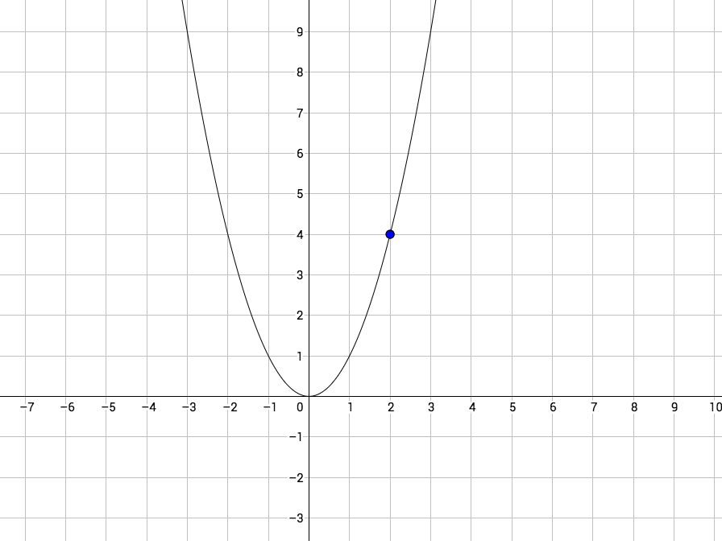

**This is the curve of an ordinary quadratic graph, $y=x^{2}$**

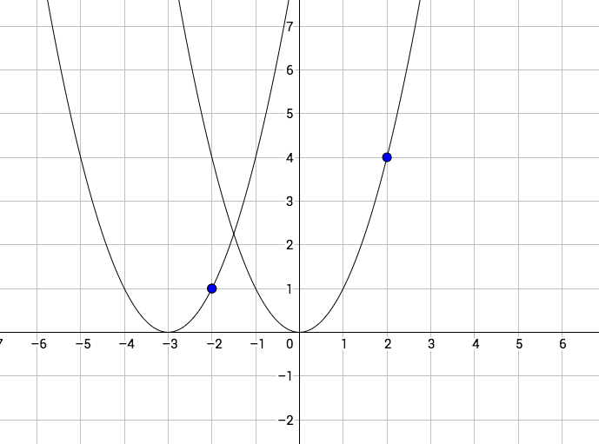

**This is the curve of another graph, $y={\left(x+3\right)}^{2}=x^{2}+6x+9$**

**So the axis of symmetry of the graph $y={\left(x+3\right)}^{2}$ is $x=-\frac{b}{2a},$ which is $x=-\frac{6}{2×1}=-3$**

**Remember, the constant c is independent in founding the positions axis of symmetry.**

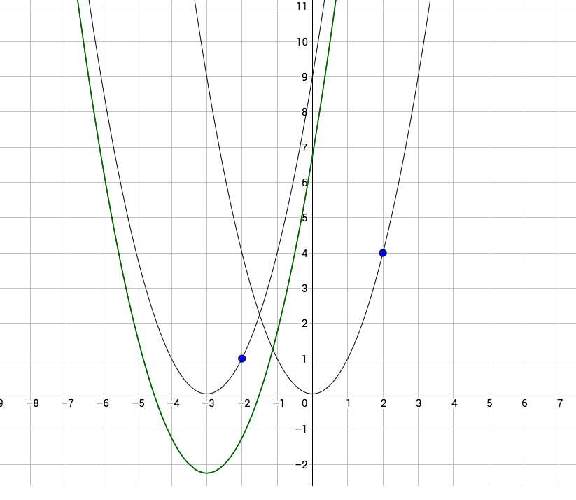

**This is a graph of $y=x^{2}+6x+6.75$, by completing square, it is $y=({x+3)}^{2}-2.25$**

**Exercise 2**

**Find the following axes of symmetry of the following function.**

$a) y=x^{2}+4x$ $e) y={-5x}^{2}+10x+21$

$b) y=4x^{2}+4$ $f) y={3x}^{2}+8x+1$

$c) y=x^{2}+4x+4$ $g) y=3{.5x}^{2}+4.25x+41$

$d) 2 y=x^{2}+4x$ $h) y=-3{.5x}^{2}-14.25x+71$

**Main Concept 3**

**Finding the vertex of the curve**

**When $(x=-\frac{b}{2a})$, then put it into the equation, we get**

$$f\left(-\frac{b}{2a}\right)=a{(-\frac{b}{2a})}^{2}+b(-\frac{b}{2a})+c$$

$$f\left(-\frac{b}{2a}\right)=\frac{{ab}^{2}}{4a^{2}}-\frac{b^{2}}{2a}+c$$

$$f\left(-\frac{b}{2a}\right)=\frac{{ab}^{2}-2a\left(b^{2}\right)+c(4a^{2})}{4a^{2}}$$

$$f\left(-\frac{b}{2a}\right)=\frac{4ca^{2}-ab^{2}}{4a^{2}}$$

$$f\left(-\frac{b}{2a}\right)=\frac{4ac-b^{2}}{4a}$$

**Therefore, the minimum/maximum point is given by $(\frac{-b}{2a},\frac{4ac-b^{2}}{4a})$ or $(\frac{-b}{2a},\frac{-△}{4a})$**

**Exercise 3**

$a) y=x^{2}-4x$ $e) y={-5x}^{2}+10x-21$

$b) y=4x^{2}-4$ $f) y={3x}^{2}+8x-1$

$c) y=x^{2}-4x+4$ $g) y=3{.5x}^{2}+4.25x-41$

$d) 2 y=x^{2}-4x$ $h) y=-3{.5x}^{2}-14.25x-7$

**Main Concept 4**

**Solving the quadratic equations:**

**The ability to solve equations concerning the quadratic functions are important topics of this chapter.**

**Usually, we will have two sides, $y_{1}=f\left(x\right)and y_{2}=g\left(x\right), f(x)$ could be a quadratic function, and g(x) could be a constant including 0, a linear function or a quadratic function.**

**Let us explore more about quadratic equation, but first please remind the below contents**

$$f\left(x\right)=ax^{2}+bx+c$$

$f\left(x\right)=\left(ax^{2}+bx\right)+c$

$f\left(x\right)=a{(x}^{2}+\frac{b}{a}x)+c$

$f\left(x\right)=a{[x}^{2}+\frac{b}{a}x+\left({\frac{b}{2a})}^{2}\right]+c-a{\left(\frac{b}{2a}\right)}^{2}$

$f\left(x\right)=a{(x+\frac{b}{2a})}^{2}+c-a{\left(\frac{b}{2a}\right)}^{2}$**,**

**if f(x)=0, then $a{\left(x+\frac{b}{2a}\right)}^{2}=a{\left(\frac{b}{2a}\right)}^{2}-c$,**

$\left(x+\frac{b}{2a}\right)=\sqrt{\frac{b^{2}-4ac}{{4a}^{2}}}$

$x=-\frac{b}{2a}±\sqrt{\frac{b^{2}-4ac}{{4a}^{2}}}$

$x=-\frac{b}{2a}±\frac{\sqrt{b^{2}-4ac}}{2a}$

$x=\frac{-b±\sqrt{b^{2}-4ac}}{2a} or x=\frac{-b±\sqrt{△}}{2a}$

**where the $△$ is called the determinant.**

**Note that there are some possible cases happened,**

1. **Distinct real roots**
2. **Repeated roots**
3. **No solutions (no real roots)**

**1 happens when the determinant $△>0$**

**2 happens when the determinant $△=0$**

**3 happens when the determinant $△<0$**

**Exercise 4**

Find the solutions of the following equations

$a) x^{2}-1=0$ $f) {2x}^{2}+7x-1=5x+10$

$b) x^{2}-1=3$ $g) {2x}^{2}+7x-1=x^{2}+5x+10$

$c) {3x}^{2}+9x=0$ ${h) 4x}^{2}+9x-1=4x^{2}+5x+10$

$d) {3x}^{2}+8x-9=0$ $i) {3x}^{2}+4x-9=x^{2}+5x+9$

$e) {3x}^{2}+8x-1=2x+5$ ${j) 2x}^{2}+7x-1=x^{2}+5x-1$